Math 099 Week4 Group quiz on Linear Functions

Do these with your group. Submit only one copy per group; all members of the group will get the same mark. Show any steps you used in your solutions. In other words, do not just post the answers.

Find equations for lines given the information.
1. If you use standard form, remember to use integral coefficients with a positive leading coefficient. Qu #1 is an example of this.
Rewrite with integral coefficients and a positive leading coefficient
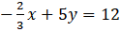
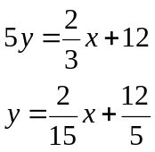

Find equations for lines given the data in each example. Use any format.

2. Slope ½; passing through (3, 2)
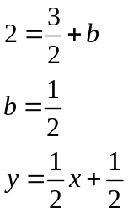

3. passing through (4, -2) and (4, 5)

x = 4

4. y-intercept 5; slope 0
y = 5

5. passing through (2, 4); parallel to
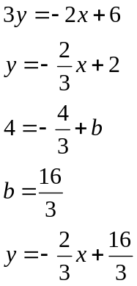

6. Find an equation for a line perpendicular to the line

- Draw a sketch of the graph. This is just a sketch, the purpose of which is to show the slope and the y-intercept.

- Express the equation in both slope-intercept form and in general form

Slope-y intercept form: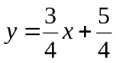

General form: 3x+4y+5=0

